Technical Design Document
Name: Slade
Course: COP 2373
Program Description
The purpose of this program is to allow the user to enter a paragraph and display each individual sentence along with the total number of sentences. The program uses Python's regular expression module (re) and the look-ahead feature discussed in Section 7.4 of the textbook. It can recognize sentences that begin with capital letters or numbers and uses punctuation such as periods, exclamation marks, and question marks to identify sentence endings.

Function 1: split_sentences(paragraph)
Description:
This function separates the paragraph into individual sentences using a regular expression.
Parameters: paragraph: The paragraph entered by the user.
Variables:
- pattern: Stores the regular expression used to identify sentences.
- matches: Stores the sentences found by the regular expression.
- sentences: Stores the cleaned list of sentences.
Logical Steps:
- Create a regular expression pattern that identifies sentence beginnings and endings.
- Use re.findall() to locate sentences in the paragraph.
- Remove unnecessary whitespace from each sentence.
- Return the list of sentences.
Return Value:
Returns a list containing the individual sentences found in the paragraph.

Function 2: display_sentences(sentences)
Description:
This function displays each sentence separately and prints the total number of sentences.
Parameters:
- sentences: A list of sentences returned by the split_sentences() function.
Variables:
- number: The number assigned to each sentence.
- sentence: The current sentence being displayed.
Logical Steps:
- Loop through the list of sentences.
- Display each sentence with its corresponding number.
- Count the sentences using the length of the list.
- Display the total sentence count.
Return Value:
None. The function prints the results to the screen.

Function 3: main()
Description:
This function controls the program and coordinates the other functions.
Variables:
- paragraph: Stores the paragraph entered by the user.
- sentences: Stores the list of sentences returned by split_sentences().
Logical Steps:
- Ask the user to enter a paragraph.
- Remove unnecessary whitespace from the input.
- Check whether the user entered a paragraph.
- If the input is empty, display an error message.
- Call split_sentences() to separate the paragraph.
- Call display_sentences() to show the sentences and their count.
3. Testing
The program was tested using a paragraph containing four sentences, including sentences beginning with numbers.
Test Input:
2025 was a busy year. I studied Python. The U.S.A. has many people. 42 students attended the class!
Expected Output:
- 2025 was a busy year.
- I studied Python.
- The U.S.A. has many people.
- 42 students attended the class!
Sentence count: 4
The program successfully displayed the individual sentences and the total sentence count for this test.
Screenshot of Testing:
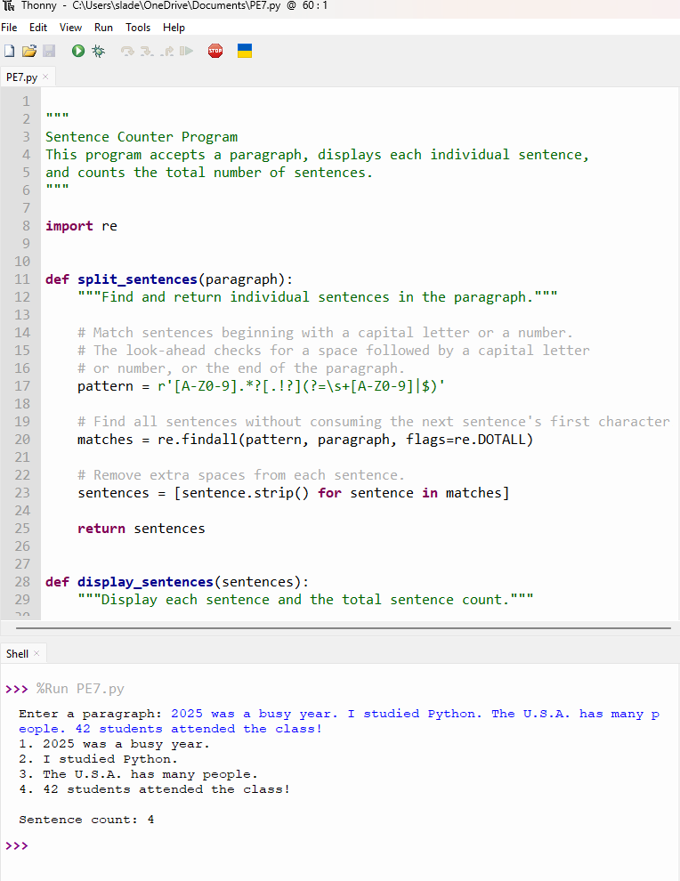

COP 2373 GitHub Repository:
https://github.com/slade963/COP2373
Conclusion
This program demonstrates the use of Python functions, regular expressions, user input, loops, and formatted output. The look-ahead feature helps identify sentence endings without consuming the characters that begin the next sentence. The program meets the assignment's goal of displaying individual sentences and counting the sentences in a paragraph.

